[GOOGLE EARTH ENGINE](EE01%20Earth%20Engine%20(EE).docx) **APPLICATION PROGRAMMING INTERFACE**

The **Application Programming Interface** (API) of Google Earth Engine (EE) is controlled like the EE GUI and most computer applications: by clicking, dragging, and/or typing in an application window or a pop-up window/menu invoked from within it. Also like the EE GUI, it requires an Internet connection.

To access the EE API, navigate to <http://ee-api.appspot.com> and click on the **Sign in** button here.

To sign in, you must use a g-mail account for which special authorization

has been granted by Google. You can apply for that authorization at [here](https://docs.google.com/forms/d/17-LSoJQcBUGIwfplrBFLv0ULYhOahHJs2MwRF2XkrcM/viewform).

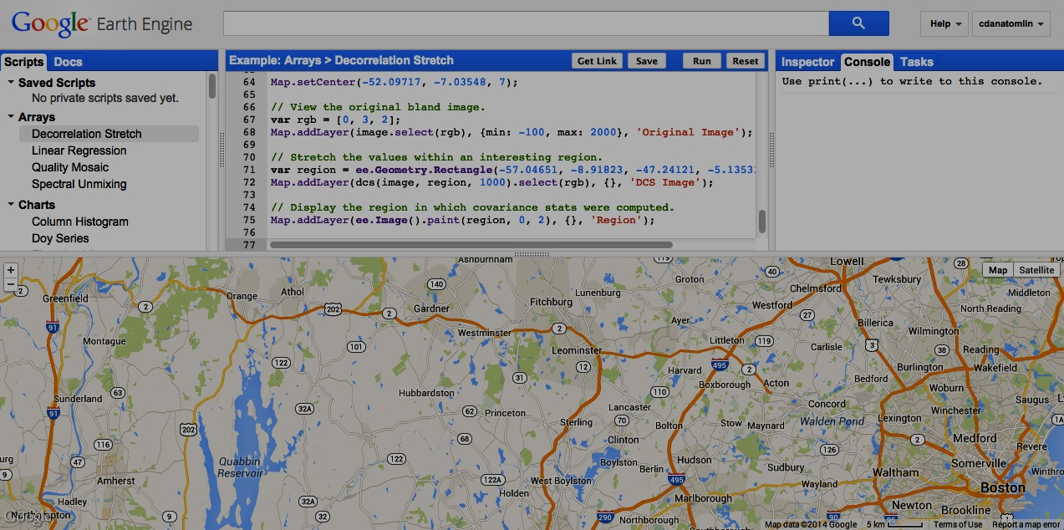

Further information on the API is organized in terms of - its [**controls**](EE06%20%20%20%20%20%20API%20Controls.docx), which can be mastered quickly, and

- its [**capabilities**](EE07%20%20%20%20%20%20API%20Capabilities.docx), which will take more time but can easily be assimilated in manageable increments.